**Name : Tanishq Thuse**

**Branch : SY-CS(AI)**

**Div : B**

**Roll No. : 60**

**Subject : ADS Assignment-4**

**Title : Implementation of Stack using Arrays and LinkedList**

**Q1) Linear search**

**Code :**

**#include<iostream>**

**using namespace std;**

**int main(){**

***//Accept input***

**cout<<"Enter size of array"<<endl;**

**int n ;**

**cin>>n;**

**int arr[n];**

**cout<<"Enter elements in array"<<endl;**

**for(int i=0; i<n; i++){**

**cin>>arr[i];**

**}**

**cout<<"Enter element to search"<<endl;**

**int key;**

**cin>>key;**

**for(int i = 0 ; i<n; i++){**

**if(arr[i]==key){**

**cout<<"Element found at index : "<<i<<endl;**

**return 0;**

**}**

**}**

**cout<<"Element not found"<<endl;**

**return 0;**

**}**

**Output :**

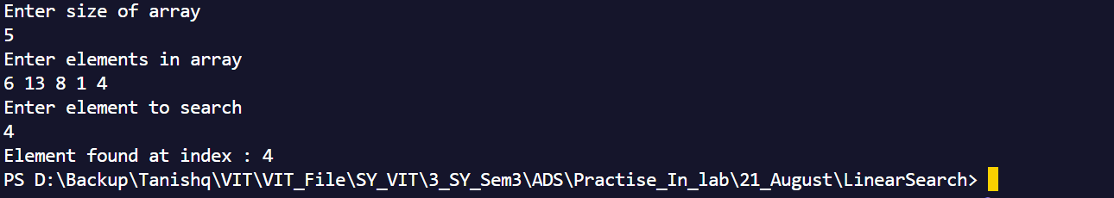

**Q2) Binary search**

**Code :**

**#include<iostream>**

**using namespace std;**

**int main(){**

**int n;**

**cout<<"Enter number of elements : "<<endl;**

**cin>>n;**

**int arr[n];**

**cout<<"Enter sorted elements in array : "<<endl;**

**for(int i=0; i<n; i++){**

**cin>>arr[i];**

**}**

**cout<<"Enter key"<<endl;**

**int key;**

**cin>>key;**

**int start = 0;**

**int end = n-1;**

**int flag = 0;**

**while(start<=end){**

**int mid = (start+end)/2;**

**if(arr[mid]==key){**

**cout<<"Element found at index : "<<mid<<endl;**

**flag = 1;**

**break;**

**}**

**else if(arr[mid]>key){**

**end = mid-1;**

**}**

**else{**

**start = mid+1;**

**}**

**}**

**if(flag==0){**

**cout<<"Element not found"<<endl;**

**} return 0;**

**}**

**Output :**

